Architecture of environment
22 May 2026 12:09:03

 | Purpose
 | Architecture of environment | 2 | / 5
 | Views
 | Test view
 | No viewpoint
 | 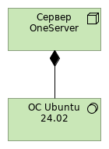
 | Elements
 | Element |  | Type
 | ОС Ubuntu 24.02 |  | System Software
 | Сервер OneServer |  | Node
 | Architecture of environment |  |  | 3 | / 5
 | Technology & Physical Layer
 | ОС Ubuntu 24.02
 | Type | System Software
 | Сервер OneServer
 | Type | Node
 | Architecture of environment |  | 4 | / 5
 | Relations
 | Composition relation
 | Type | Composition relation
 | Source | Сервер OneServer
 | Target | ОС Ubuntu 24.02
 | Architecture of environment |  | 5 | / 5

